ICTS Pilot Project’s Implementation Plan
1. Where does this project fall on the translational science continuum? (check all that apply)
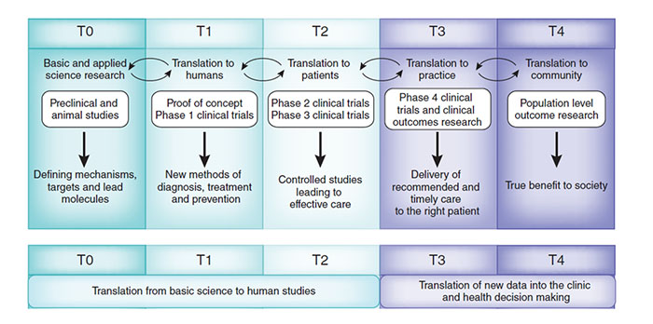
Basic Science Study (T0)
Translation of Basic Science to Humans (T1)
Translation from Human Studies to Patients (T2)
Translation from Clinical Trials to Practice (T3)
Dissemination of findings to the Community (T4)

2. What are the purposes of this Pilot Study? (check all that apply)

a. To determine feasibility of participant recruitment
b. To determine estimation of effect size
c. To determine estimation of the safety of a new procedure
d. To determine feasibility of assessment procedures
e. To determine feasibility of implementing a novel intervention
f. To determine feasibility of new methods
g. To determine feasibility of participant retention
h. To determine feasibility of preliminary hypothesis testing
i. To determine feasibility of randomization
j. To establish feasibility of a hypothesis or concept utilizing cell/molecular
approaches
k. To establish physiological relevance of an important in vitro finding in an appropriate in vivo model
l. To validate findings with cell lines in native (primary) tissue
m. To extend findings with animal models to the human situation
n.

NCATS describes a research collaboration as 2 or more individuals combining knowledge, expertise, and resources to work together in achieving a common and mutually beneficial translational research goal.

A NEW collaboration means you have never previously jointly worked on a publication, grant or presentation.

3. Is this research a collaboration? ______
a. Is this collaboration new? ______

4. Is your pilot research relevant to the following groups? (check all that apply)

a. Children
b. Under-represented populations
c. Geriatric populations
d. Rare Disease populations
e. HIV/AIDs patients

5. Will you be recruiting study participants from the following groups? (check all that apply)

a. Children
b. Under-represented populations
c. Geriatric populations
d. Rare Disease populations
e. HIV/AIDs patients

6. If you will be conducting human subjects’ research, what is the status of your IRB application?
a. Pending ____
b. Approved _____
IRB number, if approved _________
IRB date, if approved _____________
c. N/A ____

7. If you will be conducting animal subjects’ research, what is the status of your IACUC
application?
a. Pending ____
b. Approved _____
IACUC number, if approved _________
IACUC date, if approved _____________
c. N/A ____

Milestones (Milestones are intermediate objectives that are necessary steps toward project completion). Please specify the time period expected for the completion of each milestone:

Milestones are not the same thing as Specific Aims. An example of a Specific Aim is the following:
This study aims to test the efficacy a school-based evaluation to promote physical activity among sedentary adolescents.
Associated Milestones might be the following:
SAMPLE MILESTONES |  | Month of Completion  (relative to start of funding and/or actual date)
Milestone 1 | Obtain IRB approval for study | Month 1 (July, 2016)
Milestone 2 | Obtain School District approval for study | Month 2 (August, 2017)
Milestone 3 | Recruit 40 sedentary adolescents | Month 4 (Sept., 2016)
Milestone 4 | Complete baseline assessments | Months 4-6 (Sept-Nov, 2016)
Milestone 5 | Implement the intervention | Months 8-10 (Jan-Mar 2016)
Milestone 6 | Complete follow-up assessments | Months 11-12 (March/April, 2016)

8. Please list your project-specific milestones in the table below. Feel free to add more milestones if needed.

Project-Specific Milestones | Month of Completion
Milestone 1:
Milestone 2:
Milestone 3:
Milestone 4:
Milestone 5:
Milestone 6:

Anticipated date of Publication Mo/Year of Completion
If this project is expected to result in at least one publication,
Estimate the month/year that a manuscript will be submitted ___________________

Anticipated date of Grant Application
If this project is expected to result in a grant application,
Estimate the month/year that a grant will be submitted ___________________

Intended Funding Source ____________________________________________________

Anticipated ICTS Project Start Date Mo/Day/Year
___________________

